How to Set Up Chart of Accounts with Hierarchical Groups in Odoo 19
Rohan Raj | Feb 12, 2026
Hierarchical account grouping is essential for maintaining clarity in financial reporting within Odoo. Without structured account groups, financial reports become difficult to interpret and analyse. Odoo 19 enables organisations to organise accounts into clear hierarchies, improving financial visibility and ensuring consistent reporting across all financial statements.
Understanding Hierarchical Account Grouping
Hierarchical account grouping in Odoo is based on a simple idea: accounts are arranged in levels, like a tree structure, instead of being shown as a long list. This creates a clear structure that reflects how a company’s finances are organised.
For example, Assets can be divided into Current Assets, which may include Bank and Cash, followed by Bank Accounts and individual bank ledgers such as HDFC Bank or HSBC Bank. In this way, all related bank accounts are organised under the main Assets group through sub-groups.
This structure makes financial reports easier to read. Total values can be viewed at a higher level, and detailed balances can be seen by expanding the relevant section when needed.

How Account Grouping Works in Odoo 19
Account grouping in Odoo 19 is driven by account code prefixes. When a code range is assigned to an account group, any account whose code falls within that range is automatically placed under that group. For example, if the Assets group uses the prefix 10, Current Assets may use 100, Bank and Cash 1000, and Bank Accounts 10000. Individual bank ledgers such as HDFC Bank (100001) and HSBC Bank (100002) automatically fall under the Bank Accounts group because their codes begin with 10000
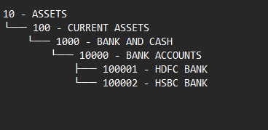

The number of digits used in account codes does not affect the grouping logic. As long as the prefix structure is consistent, Odoo correctly builds and maintains the hierarchy.

Configuring Account Groups and Ledgers
To begin grouping accounts hierarchically, open the accounting application and navigate to the Configuration tab. From there, select Chart of Accounts to review the existing accounts structure before defining account groups.
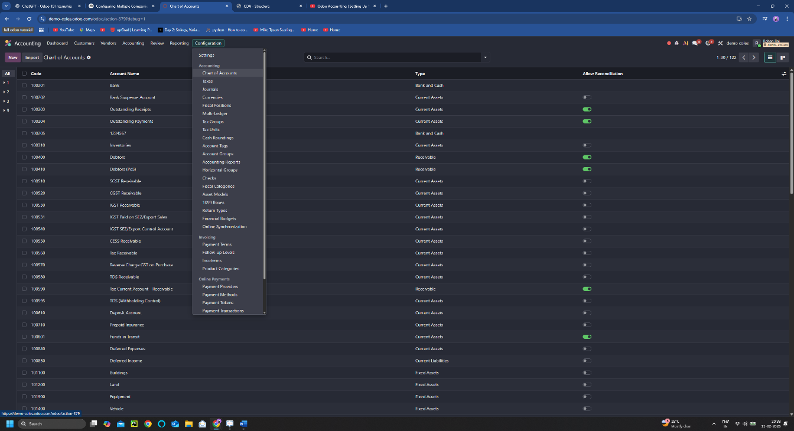
From the Chart of Accounts screen, new ledgers are created by clicking New and entering the required details such as Account Name, Account Code, and Account Type. To illustrate this structure two bank ledgers were created: HDFC Bank (100001) and HSBC Bank (100002), both assigned the account type Bank and Cash.
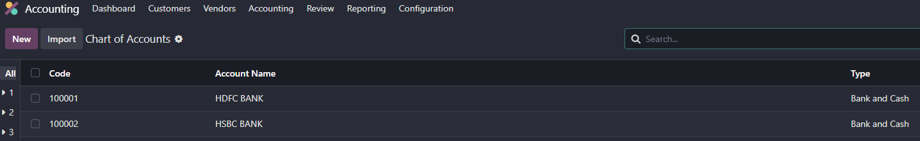
Account groups are then configured under Configuration → Account Groups. If the option is not visible, Developer Mode must be activated from the General Settings menu to make the Account Groups option available.
Within the Account Groups section, a new group named Bank Accounts was created. In the Code Prefix field, the range 10000 to 10000 was specified. This ensures that any account code beginning with 10000 is automatically classified under the Bank Accounts group.
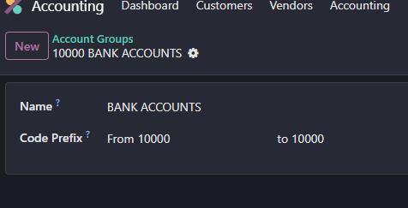
Since both HDFC Bank (100001) and HSBC Bank (100002) begin with 10000, they were automatically mapped to this group once it was saved.
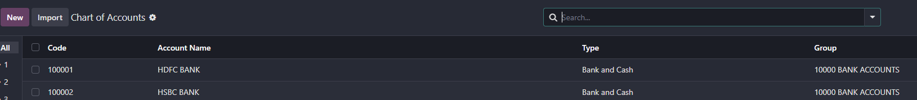

Additional parent groups were then defined to complete the hierarchy. Bank and Cash group was created to include Bank Accounts, followed by Current Assets and finally Assets at the top level. Each group was assigned appropriate code prefixes to maintain a consistent and structured arrangement.
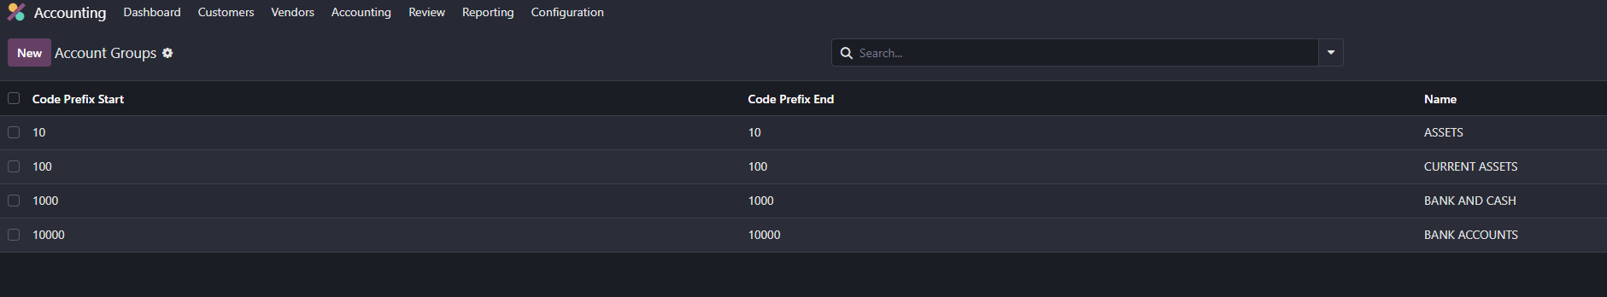
To reflect balances within the newly created bank accounts, sample journal entries were recorded using the defined ledgers.

Impact on Financial Reports
To observe how the defined account groups are reflected in reporting, navigate to the Reporting tab in the accounting application and open the Trial Balance report. The hierarchical structure can be viewed in reports such as the Trial Balance, which clearly displays grouped accounts based on the configured prefixes. With-in the report, click on Posted Entries to access the available options. From the dropdown menu, enable Hierarchy and Subtotals and select Unfold All to display the complete account group structure
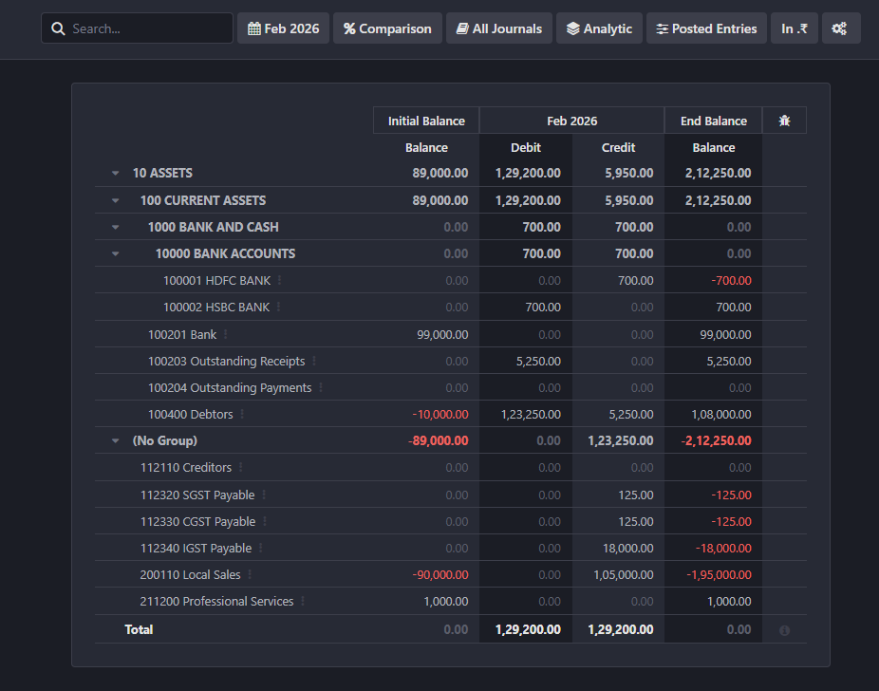
The report displays accounts in structured levels, beginning with Assets, followed by Current Assets, Bank and Cash, and Bank Accounts, under which the individual bank ledgers are listed. In addition to other existing accounts within the database, the newly configured groups appear clearly within the hierarchy. Group-level totals are shown alongside individual account balances, allowing both summary and detailed views within the same report.
In conclusion, account grouping in Odoo 19 helps to organise the Chart of Accounts into a clear hierarchical structure using code prefixes This ensures better clarity, structured reporting, and easier financial analysis.

